Shammah Thao

EEE 174 - CpE 185 Lab Section #2

Monday & Wednesday

Lab 4: PLC LAB

Dahlquist

**1.**

For this lab we have to understand plc or programmable logic controllers. We learn about the ladder logic and how it are implemented into real time system.

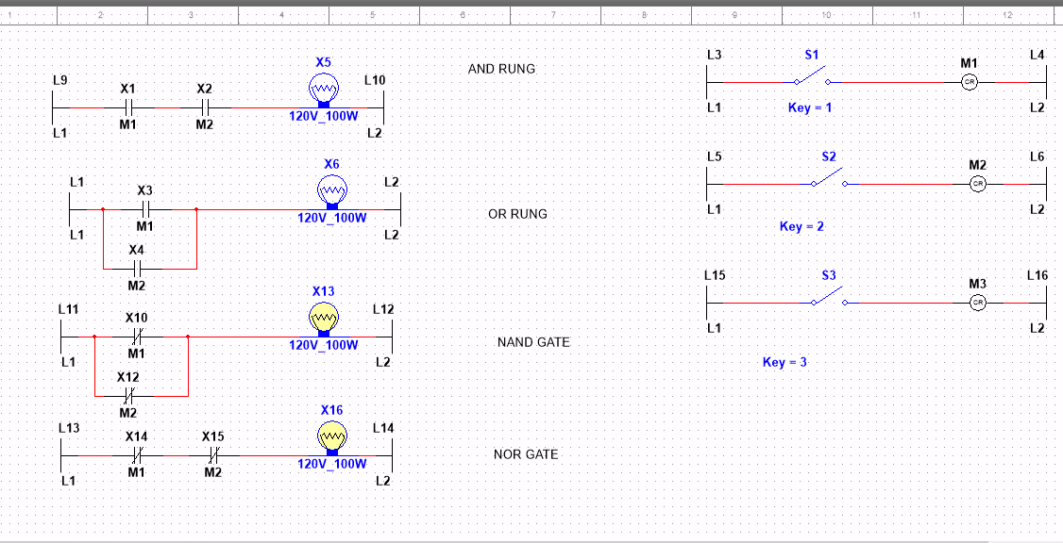

When there are no switches on the and and or gate are both off while the Nand and Nor gate are both on.

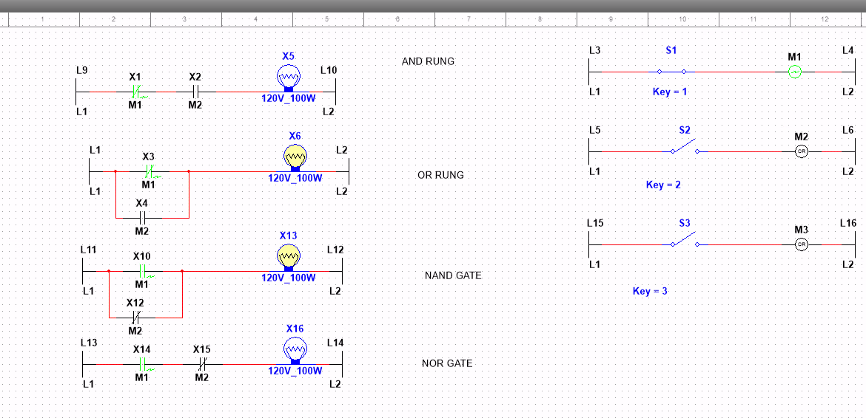

While switch 1 is activated, Or and Nand are on while the And and Nor gate are off

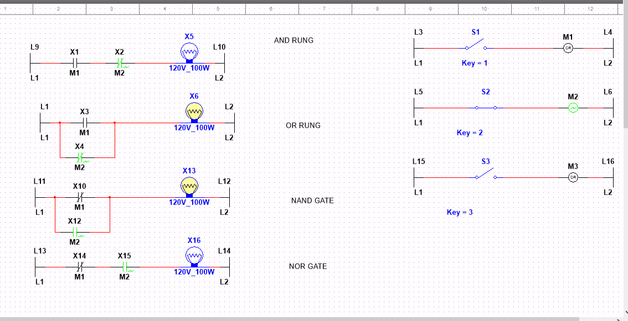

When only the second switch is on, it is the same result as the last on, only Or and Nand are on.

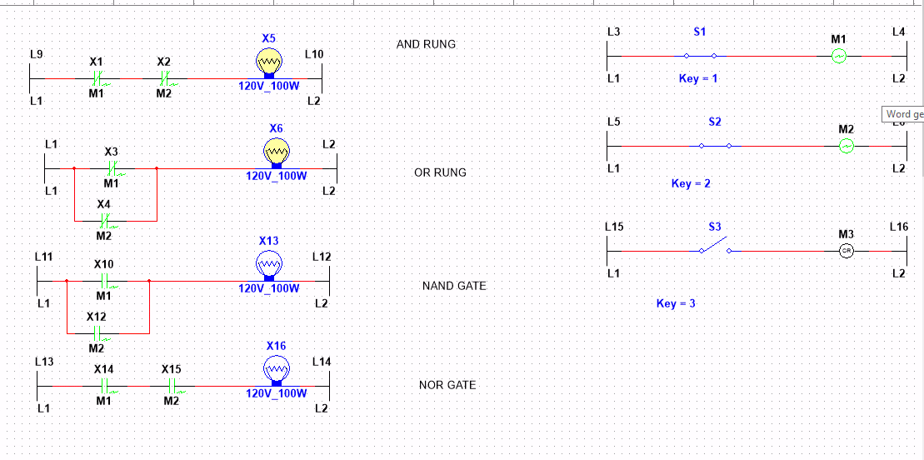

And when both switch 1 and switch 2 are on, both And , and OR rung are on while the Nand and Nor rung are off.

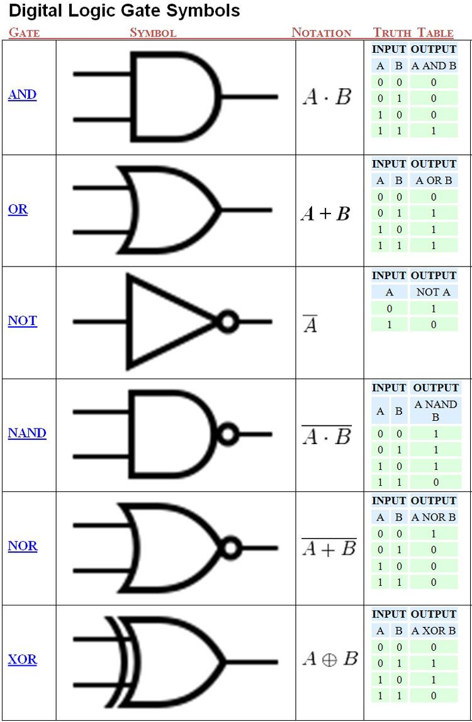

Using the following chart, we figured out the logic of each of the gates. 0 being off and 1 being on, we are able to use this to create a multi-sim, for each gates. Using the number 1 and 2 as the switch that would turn the signal to be off or no.

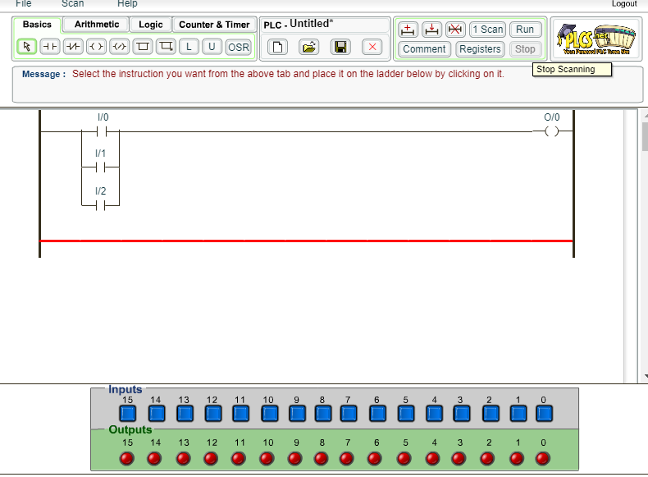

For the last part, we had to make a industrial ladder, using plc simulator. The simulator I made was about checking if doors would be detected if it has been open, like a security system.

**Conclusion:**

In conclusion this lab seems more of a refresher from cpe 64 about the gates and what its does along with how it affect and operate in the real work. There was issue with the plc simulator program running since there wasn’t much of a tutorial to learn it, but I was able to figure it out later on with the help of other people.